Strategies for Ethical Business Practices in the Global Market Place
Steven J. Clarke, Global Management Group
Peng Chan, California State University-Fullerton

Executive Summary
The central problem is globalization and international marketing ethics creates problems and negatively effects opportunities in global markets. Westerner managers wishing to take advantage of global economic growth have had difficulty in understanding the cultural differences between these foreign cultures and the west; and have negative influences on effective negotiations and strategic planning with their foreign counterparts. These processes spearhead the increasing integration of the production of goods, services, ideas, culture, communication, and the environment, effecting local populations and labor. (Yucel, Elibol, & Dagdelen, 2009, p. 93) Previous study on ethics regarding the global marketplace has a long and complicated history, with the objective to understand, control, regulate, and legislate the ethical conduct of individuals and corporations. This paper is a qualitative narrative suggesting the requirement that global companies act ethically in trade and mercantile interactions, and the theory that business institutions contribute to society, has long been studied and debated. There is no one single definition of ethics; in fact, many groups of ethics require consideration strategizing marketing activities and behavior. The purpose of this paper is to research and develop a global market strategy for ethical practices. This researcher has assimilated a number of ethical categories, factors, considerations (see Table 1), defined, and described, to help focus on corporate responsibilities in marketing globally, and as a result, strategies that consider as many factors as possible. The word ethics is derived from the Greek word ethos, which means, "character”, and from the Latin word mores, which means "customs.” Aristotle was one of the first great philosophers to study ethics. To him, ethics was more than a moral, religious, or legal concept. He believed that the most important element in ethical behavior is knowledge that actions are accomplished for the betterment of the common good. He asked whether actions performed by individuals or groups are good both for an individual or a group and for society. To determine what is ethically good for the individual and for society, Aristotle said, “it is necessary to possess three virtues of practical wisdom: temperance, courage, and justice” (The Free Dictionary, n.d., para. 2).
Business and ethical behavior are linked to the general standards of each individual society. This advocates the argument that the business community should encourage the high standards of ethics and social responsibility in each market in all practices. The complexity and difficulties of formulating effective, cross-cultural corporate ethical strategies requires investigation into governments, corporations, and society overall, in order to adopt ethical practices, customized for each situation. From a long-term, global perspective, personal, and corporate ethics are paramount to all foreign markets as globalization continues to expand. Major driving forces for strategic business ethics suggest understanding the increasing importance and opportunities facing a complex globally oriented business for long-term success. Improved business performance, profits, and economic progress come to those who effectively and efficiently foster and meet the reasonable expectations of the corporate political, social, economic and technological stakeholders (see Figure 1). The debate between ethics and profit, or the corporate ethics dilemma, is based on conflicting values and goals. “Given the vast differences in social laws, cultural and religious influenced codes of conduct, and economic and environmental conditions, not everyone has a uniform mind-set as to the right course of action to be taken when a moral question arises”(Beer, 2010, p. 2). While some debate the degree of prioritization between components of ethical behavior and profits, companies are benefitting from the understanding that long-term aspects of ethics, integrity, credibility, track record, creativity, innovation, professionalism and corporate governance. Thomas Friedman, in his New York Times column “We need to re-establish the core balance between our markets, ethics and regulation” ("Profits, Ethics, and Trust," 2009, para. 1) See Figure 2, the World’s Most Ethical publicly traded companies, consistently outperforming the S&P 500 companies between 2007 and 2011. These findings support the importance of ethical practices in the global market and provide the foundation for the following strategy for ethically responsible global marketing advances the concept that profits and ethics are not mutually exclusive. Profit maximization is not a dirty concept, without profits, companies will not survive to provide products and services in globalized economies. Further, it is not a contradiction for people and corporations to be good and do well.
Introduction
Recent hatred of corporations, even capitalism has been growing due to corporate unethical behavior and practices. Adam Smith discussed in his book, “The Theory of Moral Sentiments”, his belief that “we are all born with a ‘moral sense’, equipped with consciences” (Lennick & Kiel, 2006, para. 4). Because of this assumption, he thought that the “invisible hand” of economic self-interest governs the people’s moral sense. Research for ethical marketplace strategies will comprise factors and considerations including role of management, customer relationship management (CRM), corporate social responsibility (CSR), obligations and interests of all stakeholders, cultural, political, legal, and code of ethics issues affecting the ethical decision-making processes for companies entering or expanding into foreign markets. Additional analyses involve identification of skills and competencies that allow managers to maintain profit incentive goals, while honoring the values of moral principles including integrity and social responsibility. Further examination incorporates values, principles, and practices of corporate code of ethics in conjunction with the company’s mission statement and policies. Marketing strategies are the second step of the marketing process. The purpose of this paper is to research and develop a market strategy for ethical business practices in the global marketplace and apply these principles as they relate to the marketing mix, the 4Ps (product, price, place and promotion). The research and marketing strategy will support the hypothesis that profits and ethics are not mutually exclusive: Companies can direct their assets and capabilities to maximizing profits by way of ethical market and marketing practices, or while doing so in a “good” way.
Research
The Role of Management
The role of management should be oriented towards satisfying the customer and stakeholders needs, while not harming society. Management provides the moral compass that is the basis for ethical decision-making and strategic market goals, objectives, activities, relationships, and market plan development. Understanding of other cultures and appreciation of the differences, can enhance the communications process, but requires guidelines in proper ethical behavior. Governments also participate in control of ethical behavior, exemplified by the US Foreign Corrupt Practices Act of 1977. Corporate laws and codes of ethical behavior also provide guidelines for employees in dealing with customers, vendors, and all other stakeholders involved in managing, negotiating, and other daily activities and behavior in all relationships.
As early as 1780 B.C, Hammurabi’s Code of Laws offer what many consider “the earliest-known example of a ruler proclaiming publicly to his people an entire body of laws, arranged in orderly groups, so that all men might read and know what was required of them. The code was carved upon a black stone monument, eight feet high, and clearly intended to be read in public view”(Horne, 1915, para. 2). Some argue that ethics is the scientific or philosophical treatment of morality. Numerous great minds throughout history have advanced ideas of ethics, including Pythagoras (582-500 B.C.), Heraclitus (535-475 B.C.), Confucius (558-479 B.C.), Socrates (470-399 B.C.), Plato (427-347 B.C.), John Stuart Mill (1806-1873), Emmanuel Kant (1724-1804), and Bertrand Russell (1872-1970). In Roman times, the emperor Justinian was the first to incorporate ethics into the legal system and to establish schools to educate lawyers concerning ethics morality, and law. Napoleon established a code of thirty-six statutes based on the concept that all citizens, regardless of circumstances of birth or social stature, should be treated fairly and equally. Indeed, every civilization has recognized the need for establishing laws and codes to guide human relationship and behavior (Metcalfe, 2003: 74). (Yucel, Elibol, & Dagdelen, 2009, p. 97)
Business, like society, needs ethical guidelines. Management’s role includes setting the “codes” for behavior as part of the corporate objectives and methods of implementation in order to meet the goals of the mission statement and achieve long-term profitability. Global marketing of a company requires a detailed strategy covering all aspects of activities facing the company in the new market. Both effective and ethical market/marketing program blends all the marketing mix, consisting advertising, sales, promotion, public relations, personal selling, and direct marketing. ("Ethics Officers in Large Organizations”, 1999, p. 265). In order to address all aspects of processes that affect the final market/marketing plan, it is necessary to address and organizing codes, or ethical behavior practices, throughout the foreign enterprise requiring review, through the proposed checklists, provided as management tools for initial review, understanding and planning reflected in the following:
- Consequences and Rewards for Corporate Ethical Behavior – See Table 2
- Market Mix, product, price, place, and promotion (4Ps) – See Table 3
- Political, economic, social, and technological (PEST) – See Table 4
- International Ethical Marketing Problems – See Table 5
Management’s role requires scrutiny of home country and host country stakeholder pressures, (see Figure 3), recognizing that multinational corporations face very real pressures involving, production, product, selling, marketing, standards, practices, ethics, laws, culture, customs, systems of governments, and socioeconomic systems. Management needs to establish an environment that fosters ethical behavior. Establish codes of conduct, based on international law and global codes of conduct (see Figure 4) require understanding in order to apply appropriate ethical principles.
Getz (1990: 567-577) analyzed international codes of conduct in four entities: (1) the
Organization for Economic Cooperation and Development (OECD), which is the primary policymaker for industrialized nations, (2) the International Chamber of Commerce (ICC), which is concerned with fair treatment among multinational corporations, (3) the International Labor
Organization (ILO), which is concerned with direct investment in developing countries, and (4)
The Center for Transnational Corporations (CTC), whose objective is to maximize the
Contributions of transnational corporations to economic development and growth and to minimize the negative effects of the activities of these corporations. (Mahdavi, 2005, p. 6)
Ethical principles vary by nation resulting in the need for additional examination of how these codes related to each other, or how they compare in order to determine standards development, understand disputed standards and where agreements exits between the home market and the host market. As seen in Table 6, the United States is compared or “inter-rater” agreement with 20 other nations, providing averages of agreements between home and host country standards, disputed standards and agreements as a percentage. Shown in Table 7, is the percentage of US standards found in other nation’s codes in various US codes classifications. These comparisons provide a basis for approaching codes of behavior between countries when developing market expansion strategies. The application of these principles starts with the following management objectives and the process of asking and answering the ethical questions.
- All management levels committed to high ethical standards and corporate culture
- Integrate ethics into global strategies
- Define authority and guidance
- Management involvement in answering ethical choice questions in home-country versus host-country environments:
- What ethical standards will be used?
- Which ethical standards will transcend national boundaries?
- What work and product safety standards will be followed?
- What constitutes fair treatment of stakeholders?
- What health standards will be followed?
- What discrimination standards will be used?
- What will minimum pay and compensations standards are used?
- What are the rights of consumers in the foreign market?
- What environmental protection standards will be followed?
- Clear and detailed statements of policies and operating procedures
- Create global codes of conduct based on the following questions:
- Is it legal?
- Is it consistent with our company policy ethics?
- Is it consistent with the good intentions and core values of our company?
- Would it pass the test of public scrutiny?
- Discussion and training of policies and procedures for all stakeholders
- Communication capabilities, (hotlines and helplines), direct management access
- Commitment to investigation, follow-up, reporting and disclosure of ethical failures
- Create ethical impact statements and audits

Global Institutions
Global managers have numerous options available to them for support, research, and development of ethical practices. Depending on the home country, local offices of organizations such as the United States Chamber of Commerce, offer support in market entry and expansion development. All categories of business are available, including customs and traditions, laws, regulations and networking capabilities collaboration. Other than small membership fees, there are no direct costs for support by the Chamber. Organizations like ETHISPHERE Institute, sponsor events like the 4th annual Global Ethics Summit 2012. Attended by CEOs, Board Chairs, GRC leaders, and government and regulatory officials, the event offered critical and timely insight into the challenges compliance and ethics professionals face while navigating an increasingly complex and daunting global legal landscape. “Their mission is to “help corporate executives guide their enterprises toward gaining market share and creating sustainable competitive advantage through better business practices and corporate citizenship” (ETHISPHERE, n.d.). Depending on the host country, additional resources for support include local government offices and officials, industry trade groups, business associations, universities and other non-governmental organizations (NGO’s). Additional institutions include the “General Agreement on Tariffs and Trade” (GATT) and its successor, the “World Trade Organization” (WTO); the “International Monetary Fund” (IMF), the “World Bank”; Organization of Economic Co-Operation and Development, (OECD); and the “United Nations” (UN). Each has supporting agencies, departments to support businesses in all areas of foreign market development, including ethical considerations.

Culture
“Culture is the collective programming of the mind distinguishing the members of one group or category of people from others” (Geert Hofstede, n.d., para. 1). Understanding cross culture differences is paramount for global managers in all areas of the business. A cultural analysis serves as a starting point for follow-up strategic development for the business, based on adjustments made because of the cultural implications, which will influence the corporate culture, structure, practices, products, services, and marketing. The cultural country analysis should include:
- Research the country’s history to identify those aspects that will affect a company’s market strategies. This requires careful consideration and attention to the host country’s interpretation of their history, not just the home country interpretations. Specifically research and identify any actual or potential ethnocentric attitudes that might affect the company business based on home country or your brand.
- Geographical setting is an element of the environment that is uncontrollable but deserves attention. It is an understanding of how a country’s physical makeup affects its culture and economy. Often, rural and urban consumer purchase patterns vary in significant ways. Additionally, racial makeup, and cultural differences within a country, alters the geographic approaches for market decisions, including ethical behavior.
- Social institutions, including family, education, political and the way people relate, and organize their activities, influence market decisions, and promotional approaches.
- Religion and how these elements contribute to the culture and affect their actions
- Living conditions include the economic data and demographics, the family and general population characteristics and factors that influence their behavior.
- Language is important in order to decipher facts and identify nuances.

Political
Ethics and politics in foreign markets affect both businesses and consumers. Business managers, marketers, must also evaluate the political environment in each market, including the types, ideologies, and goals of government, in order to develop ethical and effective market strategies and practices through research, analysis, and understanding of the following:
- Political Types
- Common Law = Tradition, precedent, and usage
- Civil Law = Codified rules and statutes
- Theocratic Law= Religious teachings form law
- Political Ideologies
- Totalitarianism = All aspects of citizens lives are controlled and order is preserved
- Pluralism = Private and public organizations balance each other’s powers
- Anarchism = Only individuals and private groups can preserve personal liberties
- Political Goals
- Provide stable business environments
- Develop infrastructure and constantly improve business communications
- Develop efficient distribution and logistics systems
- Promote and effectuate equitable dispute resolution
- Continuous support of innovation, creativity to expand opportunities
- Reduce risk levels as much as possible
- Encourage Corporate Social Responsibility (CSR)
- Reduce bribery and corruption
- Improve labor conditions and human rights
- Practice fair trade
- Protect the environment and conserve resources

Legal
Management and marketing managers have numerous considerations in practicing successful and ethical practices in foreign markets. Ethical choices in international law require evaluation of ethical imperialism and cultural relativism, between home country and host country in order to determine the proper mix for marketing, see Figure 4. Evaluation of the variance in foreign laws can be categorized into the following:
- Standardization – Interpreting and applying laws uniformly within countries
- Product Safety and Liability – Responsibility for damage, injury, or death
- Taxation – Income, sales, consumption and VAT
- Antitrust Laws – Prevent market sharing, price fixing, and unfair advantage
- Legal structure of organizations, ownership, partnerships and networks
- Advertising and promotional considerations
Home country laws, such as the U.S. Foreign Corrupt practices Act of 1977, require adherence by home country managers working in foreign markets in addition to host country laws. This can be a very complicated and blurred line in the area of bribes, commissions, and general corruption levels in individual host countries. Additional research into corruption in foreign markets can be found at the OECD and UN. “Corruption is a complex social, political, and economic phenomenon that affects all countries. Corruption undermines democratic institutions, slows economic development and contributes to governmental instability” (United Nations Office on Drugs and Crime, 2012, para. 1). The issue of corruption has significant cultural and ethical considerations as what may be unethical or corrupt in one country, may be considered a commission in another. Corruption comes in several forms: bribery, embezzlement, and abuse of power as examples and have different targets including consumers, businesses, and civil servants. Strong consideration by management for developing local legal support, and/or consulting enhances the opportunities for meeting legal requirements and using ethical practices to the advantage of the business.

International Marketing Plan Guidelines Overview (Focus on Marketing Mix)
A specific, detailed, target market plan for products, prices, places, and promotions require customization based on all the research mentioned in this paper, targeted on the specific country, industry and company goals, and objectives as set forth by management. As a guideline plan for marketing, each of the following activities should be focused on each aspect of the marketing mix, in order to achieve financial success, intended market share, utilizing CRM and taking into account CSR, and accomplish all of these within ethical practices.
- Research and understand culture and language of the host market. Evaluate the markets from an internal and external set of observations methodologies.
- Adjust the product or services, including standards and product specifications) to satisfy company and host market goals and requirements, while also meeting or surpassing CRM and the customer’s requirements and expectations.
- Promote the product or services with advertising and marketing that demonstrate CRM principles and addresses the rational and emotional nature of the consumer market. Evaluate the host market media, mechanics, cost structure, effectiveness, and cultural selling features. Specific attention should be given to the brand, logo, trademarks, corporate image, and characteristics that might be interpreted differently in the host country from the home country.
- Develop a pricing that meets the costing, market share and revenues desired, based on taking into account host country constraints and opportunities. Consider all internal (market mix strategy, costs and organizational) and external (market demand/supply, competition and environmental) pricing considerations.
- Develop distribution and logistical channels from production to customer point of purchase, based on all required legal, regulatory, political, and cultural issues, including partnerships that may require working with non-company personnel. This could require negotiations, contracts, and training to sure the success of the program and to insure ethical practices are maintained.
- Develop the communications, command, and control network, through human interaction and technological requirements as necessary to maintain “hands-on” management with effective audits and oversight to insure efficiency in all areas and ethical practices compliance. Research and develop all necessary host country legal, marketing, logistical, and governmental support.
- Develop and require effective, efficient, and ethical products and services based on understanding host market lifestyles, requirements and purchase capabilities. Constantly require innovation, creativity, and improvement in all areas of product mix, customer relations, and ethical practices.

Conclusions and/or Recommendations
All business firms that desire to compete successfully in the international environment should obey legal and ethical rules and regulations. To behave in an ethically and socially responsible way should be the hallmark of every marketer`s behavior, domestic or international.
The difficult international marketing issues involving ethical behavior are not always obvious. Additionally, simple right-or wrong, or straightforward solutions are also not always clear-cut for strategic practices development. In many countries, the international marketer faces the dilemma of responding to many situations where there is no local law. Where local practices forgive a certain behavior, or when a company is willing to “do what is necessary” that is favored over the company that prefers to engage in ethical practices. Often, company size, can influence ethical behavior when local practices blur the lines of corruption. Paying bribes in one country may be viewed as “fees” or “commission” in another. Whistleblowing may well be esteemed in one country, while unethical in another. Ethical business practices are defined differently in different cultures, governments, and industries. There is no correct or single approach to dealing with these differences. This blurriness of lines in ethical behavior “requires” the complete support of home and host country corporate management, clearly setting up guidelines, and codes of ethics that address the requirements of the market, the company, and society. Management by example is also paramount!
References
A survey of ethics officers in large organization. (1999). Journal of Business Ethics, 20, 265-271. Retrieved from http://www.jstor.org/discover/10.2307/25074137?uid=3739136&uid=2129&uid=2&uid=70&uid=4&sid=21101050975103

Baker, D. (2009). Ethical Issues in the Global Arena. In C. Buckhholtz (Ed.), Ethics and Stakeholder Management (7th ed., pp. 1-19). Retrieved from http://www.csub.edu/~mattaran/home2/body_content/slides/BA374/Chapter%2010.pp

Beer, L. A. (2010). A Strategic and Tactical Approach to Global Business Ethics [ISBN 9781606491461]. Doi: Retrieved from

Buchholtx, C. (2012). Corporate Governance Essentials. Retrieved from http://www.corporate-eye.com/blog/2012/08/corporate-governance/

Business Dictionary. (n.d.). http://www.businessdictionary.com/definition/ethics.html

BusinessBalls.com. (n.d.). http://www.businessballs.com/pestanalysisfreetemplate.htm

Cook, M. (n.d.). Immigration and Ethics. Retrieved from http://www.scu.edu/ethics/publications/iie/v7n2/cook.html

ETHISPHERE. (n.d.). http://globalethicssummit2012.com/

Ethics: A Very Short Introduction. (2001). Oxford University Press, 9. ISBN 978-0-19-280442-6.

Geert Hofstede. (n.d.). http://geert-hofstede.com/national-culture.html

Horne, C. F. (1915). Code of Hammurabi, c. 1780 BCE. Retrieved from http://www.fordham.edu/halsall/ancient/hamcode.asp

Investopedia. (n.d.). http://www.investopedia.com/terms/b/business-ethics.asp#axzz26Ld0eqeU

Kotabe, M., & Helsen, C. (2010). Global Marketing Manager (5th Ed.). Hoboken, NJ: John Wiley & Sons.

Laczniak, E. (2008, January 1). Ethics of Marketing. Encyclopedia of Business Ethics and Society, 1336-1343. Retrieved from http://epublications.marquette.edu/cgi/viewcontent.cgi?article=1034&context=market_fac

Leach, M. M., Glosoff, H. L., & Overmier, B. J. (2009). International ethic codes: A follow-up study of previously unmatched standards and principles. In IUPsysS Global Resource (Edition 2009 Ed.). Retrieved from http://e-book.lib.sjtu.edu.cn/iupsys/ethics/ethics2_info.htm
Lennick, D., & Kiel, F. (2006). In the balance: capitalism and ethics. Retrieved from http://www.moralcompass.com/MNCPA_Feature_April_06.pdf

Mahdavi, I. (2005,). International Business Ethics: Strategies and Responsibilities. Journal of Academic and Business Ethics, 1-6. Retrieved from http://www.aabri.com/manuscripts/09279.pdf

Merriam-Webster Dictionary. (n.d.). http://www.merriam-webster.com/dictionary/bioethics

Nadler, J., & Schulman, M. (n.d.). Introduction to Government Ethic. Retrieved from http://www.scu.edu/ethics/practicing/focusareas/government_ethics/introduction/

Profits, Ethics, and Trust. (2009, January 20). Harvard Business Review. Retrieved from http://blogs.hbr.org/hbr/nayar/2009/01/no-profits-without-ethics.html

Prothero, S. R. (2011). God is Not One: The Eight Rival Religions That runs the World. Retrieved from http://www.goodreads.com/work/quotes/10226193-god-is-not-one-the-eight-rival-religions-that-run-the-world--and-why-th

Stanford Encyclopedia of Philosophy. (2008). http://plato.stanford.edu/entries/ethics-environmental/

The Free Dictionary. (n.d.). http://legal-dictionary.thefreedictionary.com/Ethics,+Legal

The Importance of Ethical Culture. (2010). Retrieved from http://www.ethics.org/files/u5/CultureSup4.pdf

United Nations Office on Drugs and Crime. (2012). http://www.unodc.org/unodc/en/corruption/index.html?ref=menuside

Yucel, R., Elibol, H., & Dagdelen, O. (2009,). Globalization and International Marketing Ethics Problems. International Research Journal of Finance and Economics, 26, 93-104. Retrieved from http://www.eurojournals.com/irjfe_26_08.pdf
Appendix A
Table 1
Ethics Definitions and/or Descriptions with factors and considerations for global marketing strategies
Categories | Descriptions/Definitions/Considerations
Ethics | The basic concepts and fundamental principles of right human conduct. It includes study of universal values such as the essential equality of all men and women, human or natural rights, obedience to the law of land, concern for health and safety and, increasingly, also for the natural environment. (Business Dictionary, n.d)
Business Ethics | The study of proper business policies and practices regarding potentially controversial issues, such as corporate governance, insider trading, bribery, discrimination, corporate social responsibility, and fiduciary responsibilities. Law often guides business ethics, while other times provide a basic framework that businesses may choose to follow in order to gain public acceptance. (Investopedia, n.d.)
Governmental Ethics | Issues in Government Ethics:  - Whistle Blowing in the Public Sector  - Civility  - Conflicts of Interest  - Open Meetings, Sunshine Laws, and Transparency  - Lobbying  - Gifts and Bribes  - Favoritism, Cronyism, and Nepotism  - Unavoidable Ethical Dilemmas of Elected Local Officials  - Relationships Between Elected Officials and Corporations  - Personal Lives of Officials  - Dealing Ethically with the Press (Nadler & Schulman, n.d.)
Environmental Ethics | Environmental ethics is the discipline in philosophy that studies the moral relationship of human beings to, and also the value and moral status of, the environment and its nonhuman contents. (Stanford Encyclopedia of Philosophy, 2008, para. 1)
Religious Ethics | According to Simon Blackburn, "For many people, ethics is not only tied up with religion, but is completely settled by it”("Ethics," 2001, p. 9)  All religions are not the same  “On the ethics of war the Quran and the New Testament are worlds apart. Whereas Jesus tells us to turn the other cheek, the Quran tells us, 'Whoso commits aggression against you, do you commit aggression against him' (2:194). The New Testament says nothing about how to wage war. The Quran, by contrast, is filled with just-war precepts” (Prothero, 2011, para. 2)
Legal Ethics | Perceptions of sovereignty and national identity contribute to tensions between internationalizing, globalization, and sovereign power when determining national policies, laws, and regulations. Common law, civil law, culture and history all play a role in the ethical development of activities in each global market.
Media Ethics | Media Ethics is the study of the ethical issues currently confronting  Journalism and mass communication in each globally diversified market.
Bio- Ethics | A discipline dealing with the ethical implications of biological research and applications especially in medicine. (Merriam-Webster Dictionary, n.d.)
Immigration Ethics | For good or for ill, the current immigration debate takes place in the context of international law, where the moral agents are not human individuals but states. To assess immigration policy, we must look at the nature and rights of states, and, by implication, the moral responsibilities of state leaders to their citizens and to foreign nationals.(Cook, n.d., para. 1)
Cultural Ethics | In a “weak” ethical culture, ethical values are not promoted and “getting the job done” is far more important than getting the job done in the ethically right way. Basically, the strength of a company’s ethical culture is the extent to which the organization makes doing  The right thing a priority. ("Cultural Ethics," 2010, p. 1)
Note. A definition of ethics is a complicated issue. Many define them through institutions such as religion or the responsibilities inherent in citizenship. The above are not meant as “the” guidelines, definitions or inclusive of all factors regarding ethical categories and therefore no one strategy works for all businesses in all global markets. The above are only devised in an effort to address general ethical strategies for behavior in the global market, however, further review and specific research into each market, each category for each business is required.

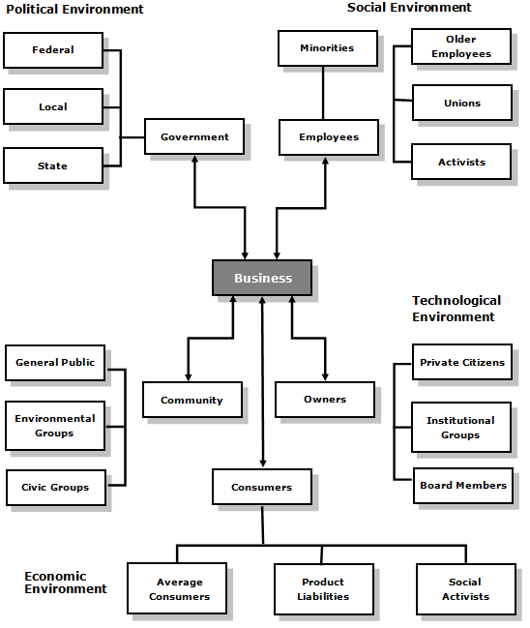
Figure 1 Corporate Stakeholders
Source: Adapted from (Buchholtx, 2012, figure 3.3)
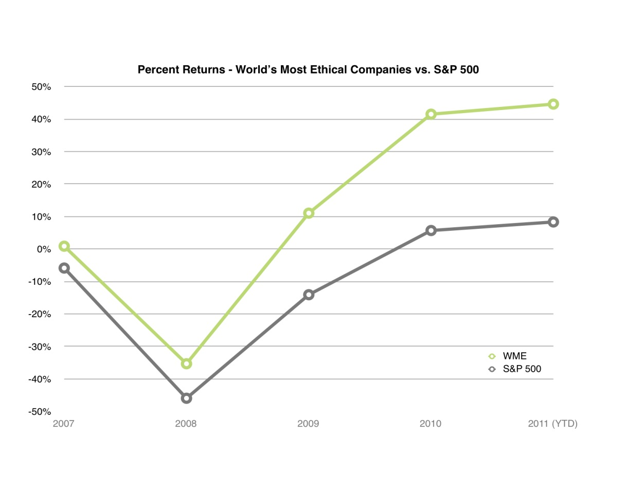
Figure 2 Percent Returns – World’s Most Ethical Companies vs. S&P 500
The above graph compares the “WME Index”, or all publicly traded 2011 World’s Most Ethical Company honorees, against the S&P 500 since the initial World’s Most Ethical Companies recognition from 2007.

Appendix B
Table 2

Consequences and Rewards of Ethical Corporate Behavior
Consequences of Unethical Corporate Behavior | - Loss of sales or service revenues  - Damage to a company’s intangible capital asset: its good reputable name or brand image  - Increased cost to reverse the first and second point as well as to settle accusations of improper conduct along with the attention and involvement of key managers, taking them away from their normal operational functions  - Alliance partners with ethical problems causing a disruption in company supply chains and an expensive interruption in business networks requiring non-budgeted switching costs  - Placing operations in a country whose government is deemed ethically repressive
Corporate Ethical Decision- Making Rewards | - Consumers with to feel that the purveyors of their needs and wants are honest in their dealings, so if a competitor falters, those with the clean record are granted an advantage  - Consumers see societal case marketing as a value added to a brand or product and are more likely to patronize firms that contribute to the social benefit of society via such combined promotional programs  - Associates like to do business with commercial partners they perceived as having a high social status in the community, thereby attracting more useful alliances  - Employees like to work for company that have a good ethical reputation, so firms can use such assets to attract the best talent  - Some shareholders only wish to invest in ethical companies, while other stakeholders, from communities to nongovernmental organizations (NGOs), are attracted to companies with a good public standing, as this attribute adds to their status and prestige.
Source: (Beer, 2010)

Table 3

Checklist of 4Ps of Marketing Mix (Product, Price, Place, and Promotion)
Product/Service | - What does the customer want from the product/service? What needs does it satisfy?  - What features does it have to meet these needs?  - Are there any features you have missed out?  - Are you including costly features that the customer will not actually use?  - How and where will the customer use it?  - What does it look like? How will customers experience it?  - What size(s), color(s), and so on, should it be?  - What is the product or service called?  - How is the product or service branded?  - How is product or service differentiated versus your competitors?  - What is the most it can cost to provide, and still sold sufficiently profitably? (See also Price, below).
Place | - Where do buyers look for your product or service?  - If they look in a store, what kind? A specialist boutique or in a supermarket, or both? Alternatively, online? Alternatively, direct, via a catalogue?  - How can you access the right distribution channels?  - Do you need to use a sales force? Alternatively, attend trade fairs? Alternatively, make online submissions? Alternatively, send samples to catalogue companies?  - What do you competitors do, and how can you learn from that and/or differentiate?
Price | - What is the value of the product or service to the buyer?  - Are there established price points for products or services in this area?  - Is the customer price sensitive? Will a small decrease in price gain you extra market share? On the other hand, will a small increase be indiscernible, and so gain you extra profit margin?  - What discounts should be offered to trade customers, or to other specific segments of your market?  - How will your price compare with your competitors?
Promotion | - Where and when can you get across your marketing messages to your target market?  - Will you reach your audience by advertising in the press, or on TV, or radio, or on billboards? By using direct marketing mailshot? Through PR? On the Internet?  - When is the best time to promote? Is there seasonality in the market? Are there any wider environmental issues that suggest or dictate the timing of your market launch, or the timing of subsequent promotions?  - How do your competitors do their promotions? In addition, how does that influence your choice of promotional activity?

Table 4

Checklist for Pest (Political, Economic, Social, and Technological) Analysis and Considerations
Political | - Ecological/environ mental issues  - Current legislation home market  - Future legislation  - International legislation  - Regulatory bodies and processes  - Government policies  - Government term and change  - Trading policies  - Funding, grants and initiatives  - Home market lobbying/pressure groups  - International pressure groups  - Wars and conflicts
Economic | - Lifestyle trends  - Demographics  - Consumer attitudes and opinions  - Media views  - Law changes affecting social factors  - Brand, company, technology image  - Consumer buying patterns  - Fashion and role models  - Major events and influences  - Buying access and trends  - Ethnic/religious factors  - Advertising and publicity  - Ethical issues
Social | - Home economy situation  - Home economy trends  - Overseas economies and trends  - General taxation issues  - Taxation specific to product/services  - Seasonality/weather issues  - Market and trade cycles  - Specific industry factors  - Market routes and distribution trends  - Customer/end-user drivers  - Interest and exchange rates  - International trade/monetary issues
Technological | - Competing technology development  - Research funding  - Associated/dependent technologies  - Replacement technology/solutions  - Maturity of technology  - Manufacturing maturity and capacity  - Information and communications  - Consumer buying mechanisms/technology  - Technology legislation  - Innovation potential  - Technology access, licensing, patents  - Intellectual property issues  - Global communications
Source: (BusinessBalls.com, n.d.)

Table 5

Checklist for Major International Marketing Ethical Problems
Traditional Small Scale Bribery | - Involves the payment of small sums of money, typically to a foreign official in exchange for him/her violating some official duty or responsibility or to speed routine government actions (grease payments, kickbacks).
Large Scale Bribery | - A relatively large payment intended to allow a violation of the law or designed to influence policy directly or indirectly (eg, political contribution).
Gifts/Favors/Entertainment | - Includes a range of items such as: lavish physical gifts, call girls, opportunities for personal travel at the company`s expense, gifts received after the completion of transaction and other extravagant expensive entertainment.
Pricing | - Includes unfair differential pricing, questionable invoicing – where the buyer requests a written invoice showing a price other than the actual price paid, pricing to force out local competition, dumping products at prices well below that in the home country, pricing practices that are illegal in the home country but legal in host country (eg, price fixing agreements).
Products/Technology | - Includes products and technology banned for use in the home country but permitted in the host country and/or appear unsuitable or inappropriate for use by the people of the host country.
Tax Evasion Practices | - Used specifically to evade tax such as transfer pricing (i.e., where prices paid between affiliates and/or parent company adjusted to affect profit allocation) including the use of tax havens, where any profit made is in low tax jurisdiction, interest payments on intra-firm loans, questionable management and service fees charged between affiliates and /or the parent company.
Illegal/Immoral Activities in the Host Country | - Practices such as; polluting the environment, maintaining unsafe working conditions; product/technology copying where protection of patents, trademarks or copyrights are not enforced and short weighting overseas shipments to charge a country a phantom weight.
Questionable Commissions to Channel Members | - Unreasonably large commissions of fees paid to channel members, such as sales agents, intermediaries, consultants, dealers, and importers.
Cultural Differences | - Differences between cultures involving potential misunderstandings related to the traditional requirements of the exchange process (e.g., transactions) may be regarded by one culture as bribes but be acceptable business practices in another culture. These practices include: gifts, monetary payments, favors, entertainment, and political contributions.
Involvement in Political Affairs | - Related to the combination of marketing activities and politics including the following: the exertion of political influence by multinationals, engaging in marketing activities when either home or host countries are at war or illegal technology transfers.

Source: (Yucel et al., 2009, p. 100)

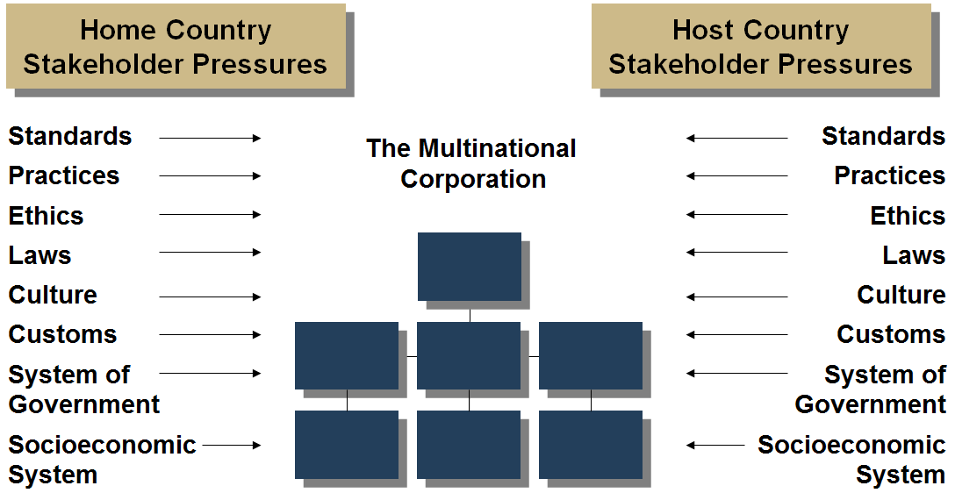

Figure 3 the Dilemma of the Multinational Corporation
Source: (Baker, 2009, Figure 10.2)

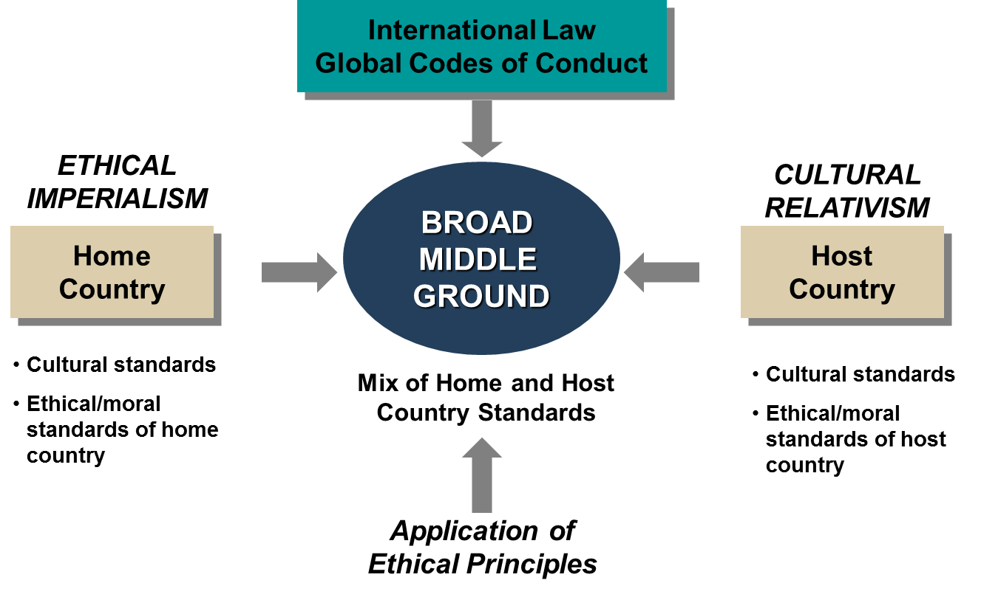
Figure 4 Ethical Choices in Home versus Host Country Situations
Source: (Baker, 2009, Figure 10-5)

Appendix C
Table 6
Inter-rater agreement and portion of other nations’ codes unmatched to the US code
Inter-rater agreement, the total standards, and principles derived per country, and the portion of other nations' standards not found in the US ethical code are indicated in Table 6. Inter-rater agreement was 88.5%. It should be noted that "individual" standards in respective country's codes might be the equivalent of two or more Standards from the US code, or vice versa. Individual standards were read for thematic content.
 | Inter-Rater Agreement |  |  | Unmatched US
Nation | Total Standards | Disputed Standards | Agreement Percentage | Standards | Percent
Australia (1986) | 104 | 10 | 90.4 | 6 | 5.8
Canada (1991) | 221 | 18 | 91.5 | 41 | 19.4
Chile (1992) | 125 | 18 | 85.6 | 45 | 36
China (1992) | 45 | 10 | 77.8 | 20 | 44.4
Dominican Republic (1980) | 51 | 4 | 92.2 | 16 | 31.4
France (1961) | 57 | 10 | 82.4 | 18 | 31.6
Germany (1986) | 129 | 19 | 85.3 | 52 | 40.3
Great Britain (1987) | 90 | 3 | 96.7 | 13 | 14.4
Hong Kong (1991) | 153 | 26 | 83 | 22 | 14.4
Israel (1991) | 70 | 3 | 94.3 | 33 | 47.1
The Netherlands (1993) | 88 | 6 | 93.1 | 37 | 42
New Zealand (1986) | 81 | 3 | 96.3 | 11 | 13.6
Poland (1992) | 85 | 2 | 97.6 | 17 | 20
Scandinavia (1989) | 121 | 16 | 86.8 | 30 | 24.8
Singapore (1985) | 97 | 6 | 93.8 | 27 | 27.8
Slovenia (1992) | 47 | 8 | 83 | 11 | 23.4
South Africa (1990) | 103 | 19 | 81.6 | 15 | 14.6
Spain (1993) | 80 | 16 | 80 | 23 | 28.8
Switzerland (1991) | 55 | 5 | 90.9 | 22 | 40
Means | 94.3 | 10.6 | 88.5 | 24.2 | 27.4
Standard deviations | 41.3 | 7.1 | 6.1 | 12.6 | 12.1
Medians | 88 | 10 | 90.4 | 22 | 27.8
Note. Total standards = Total number of US Standards and Principles identified in other code plus the number of unmatched responses;
Disputed standards = each instance of disagreement between raters (this is not the number of standards disputed. One standard might have more than one "point", so it might also have more than one instance of dispute); Unmatched = The number of instances in the code that seemed not to match any Standard or Principle in the US code. Source: (Leach, Glosoff, & Overmier, 2009, table 1)

Table 7
Indicates the percentage of US Standards found in other nation's codes by each section of the US code.
Overall means were computed by taking the total number of standards in a respective country's code and dividing by the total number of standards by section in the US code. Medians were also included because of the significant dispersion of means or the outlying scores occurring in many sections. Percent of Standards of US Code Found in the other Nations’ Codes
Comparisons were made by distinguishing the specific sections contained within the US code of ethics. As indicated in Table 4, the grand mean comparing the US code to other countries' standards was 34.5% (SD = 11.9%). Canada's ethical guidelines were the most similar code to the US code (M = 66%), and China's was the most dissimilar (M = 17%). However, the individual standards show a broad range of mean scores depending on the specific category. The grand mean for principles and standards combined was 36.5% (SD = 12.2%).
Nation | I | II | III | IV | V | VI | VII | VIII | % | P+S
Canada | 74 | 30 | 33 | 89 | 73 | 73 | 33 | 71 | 66 | 68
Australia | 33 | 80 | 67 | 44 | 64 | 42 | 0 | 57 | 46 | 49
South Africa | 48 | 10 | 67 | 67 | 45 | 46 | 0 | 71 | 45 | 48
Hong Kong | 41 | 50 | 33 | 22 | 55 | 46 | 83 | 57 | 46 | 46
Scandinavia | 52 | 30 | 33 | 67 | 73 | 27 | 0 | 43 | 42 | 44
Poland | 48 | 50 | 33 | 22 | 45 | 38 | 0 | 71 | 42 | 44
Germany | 37 | 10 | 83 | 56 | 55 | 31 | 17 | 29 | 37 | 40
Great Britain | 41 | 10 | 67 | 11 | 73 | 50 | 0 | 0 | 37 | 40
Chile | 33 | 50 | 50 | 44 | 55 | 27 | 0 | 43 | 36 | 39
New Zealand | 30 | 60 | 50 | 56 | 36 | 35 | 0 | 29 | 36 | 39
Singapore | 30 | 60 | 50 | 44 | 55 | 19 | 0 | 29 | 33 | 34
France | 33 | 50 | 17 | 11 | 27 | 15 | 17 | 14 | 25 | 27
Dominican Republic | 30 | 50 | 33 | 67 | 36 | 0 | 0 | 43 | 28 | 27
The Netherlands | 44 | 0 | 17 | 83 | 45 | 57 | 0 | 14 | 25 | 26
Israel | 26 | 10 | 17 | 11 | 45 | 23 | 0 | 0 | 21 | 25
Slovenia | 22 | 30 | 17 | 56 | 36 | 8 | 0 | 0 | 22 | 25
Switzerland | 47 | 0 | 17 | 22 | 27 | 19 | 0 | 29 | 23 | 25
Spain | 48 | 30 | 17 | 33 | 45 | 15 | 0 | 29 | 29 | 31
China | 30 | 40 | 0 | 11 | 36 | 0 | 0 | 0 | 17 | 16
Mean | 38.7 | 34.2 | 36.9 | 42.9 | 48.7 | 30 | 7.9 | 33.1 | 34.5 | 36.5
Standard deviation | 12 | 22.9 | 22.6 | 24.4 | 14.6 | 19.4 | 20.2 | 24.6 | 11.9 | 12.2
Median | 37 | 30 | 33 | 44 | 45 | 27 | 0 | 29 | 36 | 39
Notes:
I = General standards;
II = Evaluation, Assessment, or Intervention;
III = Advertising & Other Public Statements;
IV = Therapy;
V = Privacy & Confidentiality;
VI = Teaching, Training, Supervision, Research, & Publishing;
VII = Forensic Activities;
VIII = Resolving Ethical Issues; % = total hits in I to VIII / total standards in I to VIII (102);
P+S [Principles plus Standards] = total hits in Principles and sections I to VIII / number of principles plus standards
Source: (Leach et al., 2009, table 3)

ABOUT THE AUTHORS

Professor Steven Clarke (MBA) is Senior Consultant and Advisor to the Global Management Group (www.globalmanagementgroup.com), a leading consulting firm that helps US companies and executives succeed in Asia. He has consulted for Fortune 500 companies and has extensive experience in the China market. In addition, he has more than 25 years of experience in International Business at Federated Department Stores (Macy’s, Bloomingdales), May Department Stores, Carter Hawley Hale Department Stores, Eddie Bauer, National Football League (NFL), Arnold Palmer Golf Design, Central Department Stores (Thailand), Robinson Department Stores (Philippines), and #1 Department Store (China). He has also been a successful entrepreneur founding China Silk Wines, in addition to consulting foreign companies entering the Asian market. He has taught international business classes including, strategy, ethics, social media, foreign market entry, marketing, economics, organizational behavior, operations management brand development. He is a graduate of Northern Arizona University and Grand Canyon University. He is currently senior consultant for Global Management Group, International Consultants and is guest business analyst on the Nation, Sunday Night Business weekly television in Bangkok Thailand.

Professor Peng Chan is Full Professor of Strategic Management at Cal State Fullerton. He has published widely in the fields of strategy, franchising, and international business and has over 25 years’ business and consulting experience in the US and the Asia Pacific region. Dr. Chan is founder and CEO of Global Management Group (www.globalmanagementgroup.com).

